**The Big Five Animals in Africa(Prototype)**

**Purpose**

Most people travel to Africa to view famous big five game, and they go back disappointed because they would have only seen maybe 1 or 2 of the members of the big five, or even none. This is mostly because they would have been misled into believing that the big five is available in any African country and that in all game viewing places, there are all members of the big five. Here we are talking about the lion, elephant, rhinoceros, leopard, and buffalo. In most places or countries, you won’t find them all in one place. So, I want to create a non-miss adventure app that will point the game enthusiasts to the right place where they can see the majestic five all in one local and be equipped with necessary information about each member of the big five.

**Audience**

Tourists are the major target group:  
These are international tourists  
Local tourists.

**Data Sources**

**APIs list:**  
1. Africa-API(RapidAPI App), it gives a ist of resources per African country including tourism information.

2. Wildlife Database API (iNaturalist API, Global Biodiversity Information Facility) for retrieving animal data and images.

3. Google Maps API for displaying animal locations on an interactive map.

**JavaScript list:**  
1. Fetch animal data from APIs based on the selected animal.

2. Build HTML templates dynamically using the retrieved data.

3. Integrate map API to display animal locations.

4. Handle user interactions and navigation.

* **Pages:**
  + Home: Introduction to the Big Five, brief descriptions, and links to individual animal pages.
  + Individual Animal Pages (Lion, Leopard, Elephant, Buffalo, Rhino):
    - Header: Logo, navigation bar with links to all animal pages and home.
    - Content area: Dynamically generated content based on API data, including:
      * Animal description (diet, size, habitat)
      * Behavior and social structure
      * Conservation status and threats
      * Interactive map showing animal distribution
      * High-quality images
    - Footer: Copyright information, contact details, social media links.

**Fonts and Colors**

Background Color: #F1AB10/#F2DFB4

Font-family: Helvetica, sans serif

Font Color: black

**Mocks**

Wireframes: Mobile View and Full Screen

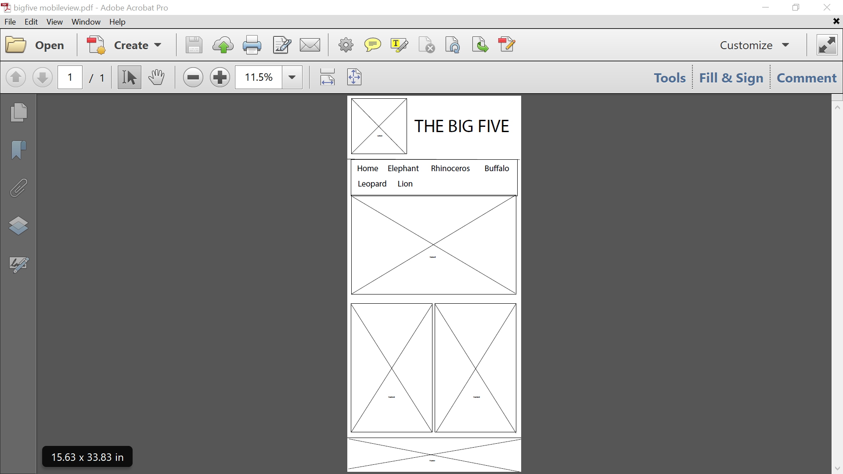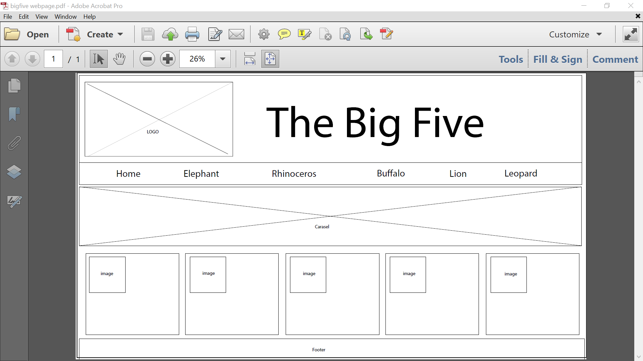

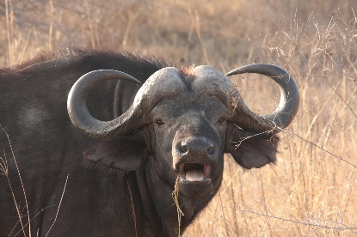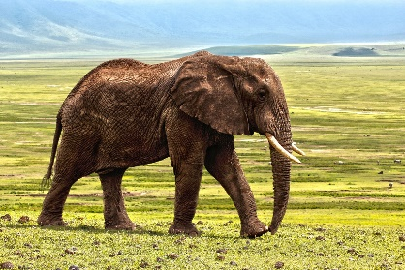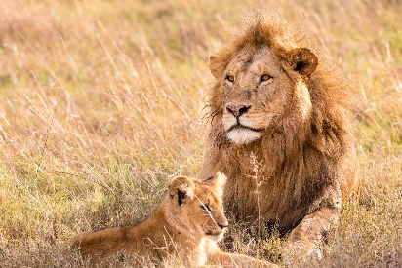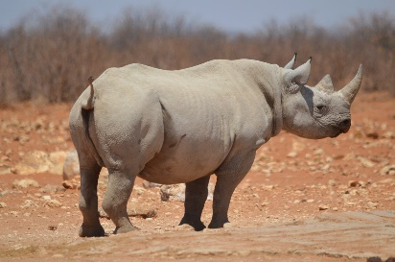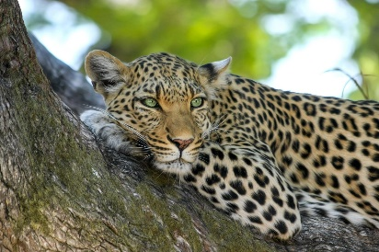

**Schedule**

Week 5 – Proposal and project setup

Week 6 – App creation, connectivity tests, pages creations

Week 7 – Testing, touchups, and launching.